Summary
IN the network storage, the organization of data optimization is one of the effective ways to improve system performance, reasonable data distribution strategy to improve storage system performance, so that the storage system with high availability, high reliability and scalability. Thus, inadequate mass data distribution strategy for the current storage system, this paper proposes an efficient data distribution strategy --FDDM (Flat Data Distribute Method). First, the data is stored as object. Then, by dividing the object ID value, which design the directory structure, the directory hierarchy. Ultimately all the data stored flat. This strategy improves the object storage systems under a single directory excessive amount of data and the problem of uneven distribution of data.Effectively optimize the overall performance of data access efficiency and systems.
Keywords: cloud storage, object storage, FDDM.

I. Introduction
` Object-oriented storage system has great advantages in scalability, reliability, security and so on ,and therefore widely used in the field of high performance computing, cloud computing. The core of the object storage system is the separation of data path and control path (metadata) . Object storage systems are mainly related to two concepts, objects and keys. [2] object is the basic storage unit of object storage system. It mainly consists of two parts: data and metadata. Data can be any type of data, including text, pictures, audio and video, and so on. Metadata is data that describes data, it is associated with a particular data, no separate. Key is a unique identifier for the object. As everyone has a social security number, each object has a unique key, otherwise the object does not make sense.
Because of many advantages of object storage system in storage environment, many companies take it as their prototype, to launch its own object-based storage service. For example: Amazon proposed the service of Simple Storage Service, and Abbreviated S3. The data is stored on storage node by object. Learned the structural model of S3 from References [1] [2],as shown in Figure 1. Where: S3 is mainly related to three concepts: Object, Key and Bucket. S3 is the basic storage unit of Object , Key is the unique identifier for the object. Bucket is a container used to store the objects , similar to the user's folder.All the objects stored in the bucket. Domestic like Ali's OSS (Open Storage Service), Tencent’s COS (Cloud Object Service), Sina’s SCS (Sina Cloud Storage) are similar to Amazon’s S3 model. The model is simple and convenient,and can meet the requirements of users of the system access performance when the system less user data. However, in the real environment, due to the continuous development of Internet technology, user data is explosive growth at an exponential rate . In this Internet environment, using storage model like s3 will result in an excessive amount of data under a single directory. Seriously affect the overall performance of the system and it’s not conducive to the dynamic expansion of post-maintenance and systems. And affect user access performance. Swift is a data distribution model object-oriented storage of OpenStack , compared with Amazon's S3 storage service, Swift uses a static catalog distribution level, to a certain degree, ease the problem of distribution of data over a single directory . Object storage hierarchy model shown in Figure 2 [Fig cited reference [6]]. Wherein: devs is the device path; object directory is the storage directory of object ; each partion directory stored under the object directory, where the distribution system of partition maps the fixed total partition to each Storage node by using consistent hashing algorithm logically.directory partition consists of several suffix_path, the name of suffix_path is after three hash_path ; hash_path consists of account ,container and object ID owned by the file. So a hash path corresponds to a unique name.suffix path constituted by the subdirectory hash path, store data and metadata information of the object under hash_path directory. Through detailed description of the swift we know directory structure of devs, object, partion are fixed before the object is stored . Therefore; the object is stored by suffix_path, hash_path directory object that implements the two distributions. Wherein the object is stored only under hash_path directory. This two-tier,static object distributed model of swift, to a certain extent, ease the problem of the distribution of data in a single directory under excessive. However, this static data distribution method is applicable to the system of a fixed number of user data level. Algorithm can not be dynamically adjusted even if the amount of user data is dynamic. Therefore, data whether distribution is heavily dependent on the amount of user data. And suffix_path layer directory capacity determination. It will lead subdirectory too much under suffix_path layer if the user of magnitude too large, , seriously affect the overall performance of the system.
To solve the problems, we propose a rational distribution strategy --FDDM (Flat Data Distribution Method) based on the data object. The data distribution strategy of FDDM is based on the method of a segmented OID. It is an extension and supplement to the existing object data distribution method. The level of he granularity division of the Catalog more detailed , combines the advantages of the file system directory and the flat distribution of object storage. FDDM policies based on the user's magnitude, dynamic configuration directory hierarchy and the capacity of each directory. Implementation strategy is not limited to the amount of user data.
FDDM strategy to achieve a uniform distribution of data with the fastest speed no matter what the user magnitude.
The rest of this paper is organized as follows: Section II describes FDDM Policy Model. Including FDDM basic framework, policy analysis and implementation. Section III experiments, analysis and evaluation of our algorithm. Finally, draw some results by experimental results.

bucket

object
object

object

key
data
metadata

figure 1：S3 basic architecture diagram
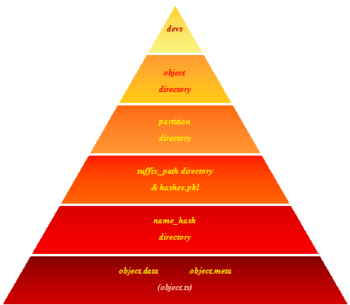
Figure 2：swift distribution model

II. The model of FDDM Policy
A. The basic architecture
FDDM strategy is an extension and supplement to the existing object data distribution method. It is a data distribution method bases on OID segmented. As required dynamic partitioning OID, Remove the corresponding part to build directory name from the division of each segment in OID. To organize hierarchy and capacity of the directory. Directory hierarchy shown in Figure 3:

devs

The directory structure
configurate dynamically

userid
FDDMdirectory

object

object
object

objectData

Figure 3：FDDM Policy directory structure

Wherein: devs: Equipment mounted path. Storage systems are user-oriented services. Therefore, the data storage units of users. Userid is the user's folder.
FDDM directory is the core of the FDDM strategy. It consists of two parts: the directory hierarchy. Another part is the maximum capacity of each directory. Wherein directory hierarchy and the the maximum capacity of each directory dynamically configured by the administrator based on the amount of data users. Finally, the last layer of directory stored the object .
For example: an object storage path shown in Figure 4, it is assumed that the directory hierarchy into two layers.
/data/
100000099
0cc175b9c0f1b6a
831c399e2697726
8fa14cdd754f91cc6554c9e71929cce7
First FDDMdirectory

objectData

devs
userid
Sec FDDMdirectory

Figure 4: Directory Structure

B. The analysis of FDDM strategy
FDDM strategy take object storage system as prototype, The characteristics of the object storage is that every object has a unique ID . And the OID structure is same in a system. Using this characteristics of the OID. Designing object storage model starting from OID.
By dividing the OID, we organize the directory hierarchy. From each divided part, take out the corresponding value according as needed. In order to improve the safety of the storage system, each part of the value of the R algoriyhm(such as MD5 encryption) process is taken as the name of each directory.
Using the OID organize the directory hierarchy, the problems are to be solved as follows:
- Directory hierarchy(how many parts the OID is divided into)
- The maximum of each directory(according to the principle of permutation and combination. Digits from every part determines the capacity of each layer of directory).
- Directory naming forms(each part taken out from the layer is treated as a directory).
First of all, studying the relation between the amount of user data and directory hierarchy. As we known, when the parent directory following too many subdirectories or files, user data access efficiency will be seriously affected. When there are too many directory hierarchy and capacity but less User magnitude. Data will be distributed too scattered, which is a waste of storage space. Therefore, a reasonable directory level and capacity determine the data distribution.
To ensure access performance, while using FDDM strategy designing object storage hierarchy structure, organizing the directory level and capacity(in this system by monitoring the system directory distribution dynamic configuration directory structure) according to the type of file system and user magnitude, guaranteeing the systems maximum access performance.
Here is a brief analysis of the order of magnitude of the user and directory level, the relationship between the capacity of each layer of the directory. (the last layer also take as a directory) study 2 ~ 4 layer mesh. For reference only.
The first thing is to divide OID, OID is usually a string of hexadecimal number, To generate OID different system in a different way. OID is divided into four parts firstly, and then according to different taken by each part number, calculating the capacity of directory.
1. Each part takes a number,Each directory capacity is as follows:
According to the principle of permutation and combination there are 16 possible of each number,because the OID is usually a string of hexadecimal number. Next,calculating the maximum total capacity of each directory level.(There are sixteen subdirectories at most under each parent directory )
The total capacity of the first directory：16
All of the subdirectories of the first directory：16*16=256
All of the subdirectories of the second directory：16*16*16=4K
All of the subdirectories of the third directory：16*16*16*16=56k
The total capacity of directories of three layers:4k
The total capacity of directories of four layers:56k
2. Each part takes two numbers,(there are most 256 subdirectories under each parent directory )Each directory capacity is as follows:
The total capacity of the first directory：16*16=256
All of the subdirectories of the first directory：16*16*16*16=64K
All of the subdirectories of the second directory：16*16*16*16*16*16=16M
All of the subdirectories of the third directory：16*16*16*16*16*16*16*16=4G
The total capacity of directories of three layers: 16M
The total capacity of directories of four layers:4G
3. Each part takes three numbers,(there are most 4K subdirectories under each parent directory )Each directory capacity is as follows:
The total capacity of the first directory：16*16*16=4K
All of the subdirectories of the first directory：16*16*16*16*16*16=16M
All of the subdirectories of the second directory：
16*16*16*16*16*16*16*16*16=64G
All of the subdirectories of the third directory：
16*16*16*16*16*16*16*16*16*16*16*16=256T
The total capacity of directories of three layers: 64G
The total capacity of directories of four layers: 256T
we can draw some conclusion from the analysis process:There are most 16 subdirectoyies under each parent directory when we take a number from each part. a maximum of 256 subdirectories under each parent directory if we take two numbers from each part .and if we take three numbers from each part, there are 4k subdirectories under each parent directories. Too many subdirectories under the parent directory if we take three numbers from each part, and affect access performance of the system seriously. If there are too much user’s magnitude, you can expand directory structure by increasing the directory hierarchy.Therefor,we only take one or two value to research the structure of the directory.
The relation between the magnitude of user,directory hierarchy,the maximum capacity of each directory and tne object capacity of last layer.
Follow as table 1：
The order of M (2²⁰ ~ 2³⁰) level of user
directory hierarchy | the maximum capacity of each directory | tne object capacity of last layer
3 | 16 | 256~256K
3 | 256 | 16~16K
4 | 16 | 1~64
The order of G（2³⁰~2⁴⁰）level of user
3 | 16 | 256K~256M
3 | 256 | 16K~16M
4 | 16 | 64~64K
4 | 256 | 1~64
The order of T（2⁴⁰~2⁵⁰）level of user
3 | 16 | 256M~256G
3 | 256 | 16M~16G
4 | 16 | 64k~64M
4 | 256 | 64~64K
Table 1: The analysis of the directory hierarchy

It can be seen from Table 1, whether the distribution of the directory hierarchy and capacity is reasonable which deeply relate with the magnitude of users data. Therefore, in order both to ensure performance of the system and does not result in the data fragmentation. Administrators can dynamically configure the capacity and hierarchy of the directory if using FDDM policy. To the rational distribution of the user data, if the User magnitude less than the level of K.You had better configure the directory for two structures, and taking a number from each section to the data spread out.
Rules of directory naming form: from the division of the OID to retrieve the value of the processed as corresponding directory name. Of course you also can not do any processing. But in order to ensure the safety and reliability of the data. General directory hierarchy and object ID is generated through special processing irregular value completely. For example, using MD5 encryption. Developers can deal according to their own requirements.
C. The implementation of the FDDM policy
According to the type of file system and the magnitude of use, to configure the appropriate hierarchy and capacity of the directory .
Assumed the directory hierarchy is n, take a number from each part of the OID division. Algorithm to generate a directory is L.
1. pseudo-code
(1) obtained the OID, divided the OID into n portions averagely; the next step.
(2)Take m-bit from each part which start from the first bit ,and then stored the value in the P [] arrays, the next step.
(3) Remove all the elements from the array p [], The elements are processed with L algorithm ,and then saved them in the array P [] ; the next step.
(4) if A = pop (p []) is null? No, A as the directory name, the next step. Yes, jumping to step(8).
(5) if A is the first element out from the array? Yes , Take the user folder as the current directory B, the next step; otherwise, the next step.
(6)Whether there are subdirectory A under the parent B? No, create a subdirectory A under B,and take the subdirectory A as the current directory B.The next step. Otherwise,take the subdirectory A as the current directory B. Go to step(4).
(7) If the array p[] is empty? No, take the current element A out from the array p[] which the pointer point to . Go to step (6).Otherwise, go to step (8).
(8) To save the object under the current directory B, Finish.

2. flow chart
The flow chart of FDDM strategy is shown as figure 5.(If i=0 take the user folder B as current directory)

start

OID is divided into n parts

Take the first m-bit value out from each part; and then storage into an array P [].

i=0

A=L(P[i])，i++
Take A as the current directory B
No
Subdirectory A already exists under the
current directory B
i>=n-1

Yes

No
Yes
Create subdirectory A under the current
directory B,Take A as the current directory B

Take A as the current directory B
A=L(P[i])，i++
No
if i>=n-1
Yes
Stored the object under the current directory B

Finish
Figure 5: The flow chart of FDDM strategy
III. Experiment and analysis
A. The prototype of cloud storage
窗体顶端
窗体底端
Before the experiment. Firstly ,briefly introduce the prototype of cloud storage system.
In order to store the user numerous data in the cloud storage system, we design a prototype of cloud storage system . It is a object-oriented storage system, and use the distribution storage architecture. The system With the properties of high scalability, high availability, high safety and so on.
A prototype of the system diagram shown in figure 6. As shown in figure 6, the entire storage system architecture can be divided into three parts: the Storage Client, the metadata server and storage resource pools. Where the client is built into the internal of the storage application system or the user , providing the communication interface between the metadata server and storage resource pools, complete data exchange capabilities between the client and the storage system.
The system encapsulates the application interface of the storage,so the meadata server clusters,the way of working and the underlying architecture of the storage resource pools is completely transparent to the client,which makes the user does not need to consider the complicated underlying structural features.It is easy to use the simple interface to make use of the storage resourse and develop the data service application. Metadata server cluster are used to manage the metadata information of the user data,the storage location of the data and redundancy policy.
Metadata server provides file IO to user,and process the operation of file-level operations from client. (upload, download, delete, play online audio and video and so on).the Pool of storage resources are made by great amount storage nodes.It is mainly use object storage technology and distributed architecture to complete
preservation of user data,and provide fault tolerance, disaster recovery and other functions of the data.
storage Client
Metadata Server

High-speed Internet system

Data
Node
Data
Node

Data
Node

Storage resource pool
Figure 6: prototype draw of the cloud storage architecture

1. Application of the FDDM policy
FDDM strategy had been achieved and applied in the system, in this section, we observe the distribution of the object data in the system by simulating S3, Swift and FDDM strategy,respectively.
The concrete realization of FDDM strategy in this experiment:
In this system,the OID is generated by md5 (uniqid (rand ())).Uniqid () function: in milliseconds of the current time, which generates a unique string.In order to ensure the security of the data.Using MD5 algorithm to encrypt produces a unique 32-bit strings. In the following experiments,the administrator configurates directory
hierarchy for two layers and takes out a number from each part. to generate directory name by Md5 encryption algorithm . To store objects under the second layer.
For Example:we will obtain a unique 32-bit OID when user uploads a file,and divide the OID value into two parts using 16 units.then get the first value of each part and stored in the array P[], each element from array P[] is encrypted by MD5 algorithm . The two 32-bit strings that use MD5 encrypted are as two layers of the object storage directory, when store data, we firstly find the user folder and then in the corresponding layer to judge whether the two layers of the directory has been created. If not, we created. Otherwise we do nothing and continue to judge the next layer of directory is created or not, if each directory has been created .The object is stored in the last layer.
The above algorithm is adopted to realize the sample of the data distribution:
Algorithm implementation as follows: assuming that the user has not uploaded
any data.
User 1,upload date A and B，assuming：
The OID of A is：d5c12521a79bb79c22debca347dbbe00
The OID of B is：d579091c5a880faf6fb5e6087eb1b2dc
The user folder is：100000001
Upload the date A:
(1) Dividing the OID into two parts[d5c12521a79bb79c;22debca347dbbe00]
(2)Taking the first number of each part[d,2]
(3)Using MD5 to encrypt [md5(d),md5(2)]
(4)Because didn't upload data anymore, directory does not exist. Therefore, creating the directory step by step, the generated directory as follows：
100000001/md5(d)/md5(2)
(5)uploading the date.
the file path is 100000001/md5(d)/md5(2)/A object ID
Upload the date B,the process is the same as A.The two directory names has generated are [md5(d),md5(6)].
(1) Found that the subdirectory of md5(d) has been created under the parent directory 100000001. Analyzing the next level is created or not.
(2)Judging whether subdirectory md5 (6) exists under parent directory md5 (d)? No, creating the subdirectory MD5 (6) .
(3)The directory structure is:
100000001/md5(d)/md5(6)/
(4) Upload files
C. Experimental environment
The configuration of the cloud storage system is as follows:
server:
OS: SUSE Linux Enterprise Server 11 SP1 (i586)
CPU: Intel (R) Xeon (R) CPU E5606 @ 2.13GHz,
DISK: 9.2G
Memory: 512M
Application Server: Apache / 2.2.10 (Linux / SUSE)
Database: mysql 5.0.67
PHP: version 5.5.16.
Identically configured server cluster system (Configmanager, ManagerServer, FileServer)
Clients:
OS: Windows 7
CPU: Intel (R) Core (TM) i5 CPU
Memory: 4G
Monitoring tools: zabbix (zabbix integrated into the system will generate a directory distribution line graph)
Testing tools: HP LoadRunner (concurrent simulated users upload data)
D. Experimental procedure and results analysis
Simulating the policy of Amazon s3,Swift,FDDM upload data.Observation of a line chat about the average change of each directory, and the distribution of the object in the system.Compare the data distribution under the three policies.
When the number of files were [0-100], [100-500], [500-1000], [1000-2000], [2000-5000],[5000-10000] ,observed the average distribution change of each
directory.In this experiment,Generally observe the distribution of the directory and the file number of relationships through a line chart when we upload files.During upload,choose a few main stable point, stop uploading files, Observe the distribution of each directory in the file system.
Observation the directory structure map of each layers under the S3,Swift,FDDM policy respectively. Wherein the first layer of S3 is the subdirectories of bucket.
The first directory of swift is named suffix_path, the second layer directory is hash_name, objects are stored under hash_name .The first directory of FDDM is the subdirectory of user folder, the object is stored in the third layer. All objects are stored in the bucket with S3 policy, so there are only one layer directory change. Known from the swift strategy: There are only a object under the directory of hash_name. Therefore we only listed the first,second directories change of swift.
Test 1: The number of object grows from 0 to 100.
(1)The number of the first directory changes under the policy of S3,swift,FDDM
as shown in a11, b11, c11.
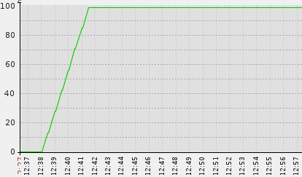
Figure a11: The line chart of the first directory changes with the policy of s3
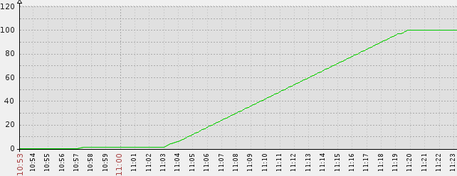
Figure b11: The line chart of the first directory changes with the policy of swift

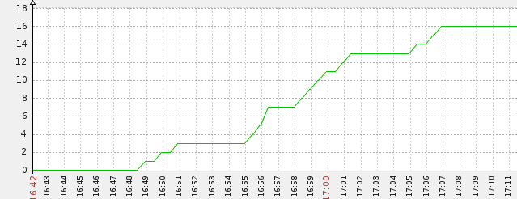
Figure c11: The line chart of the first directory changes with the policy of FDDM

Wherein: X axis is the period of time of the object number changes from 0 to 100.
Y-axis represents the number of the directory within the period of time.
(2)The number of the second directory changes under the policy of swift,FDDM
as shown in b12, c12.
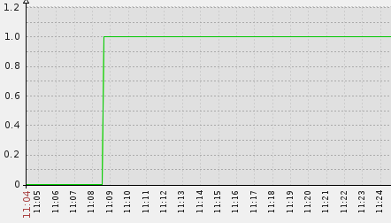
Figure b12: The line chart of the second directory average changes with the policy of swift

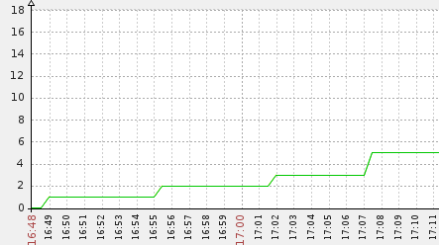
Figure b12: The line chart of the second directory average changes with the policy of FDDM

(3) The number of the third directory changes under the policy of FDDM
as shown in c13.
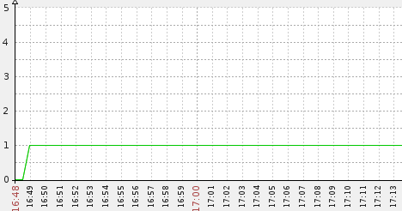
Figure c13: The line chart of the last directory average changes with the policy of FDDM

When the number of the objects up to 100.It was observed the real distribution of objects with the policy of S3, swift, FDDM in the system.
(4) The distribution of the object in the system with the policy of the S3 as shown in A11.
bucket

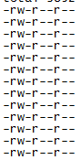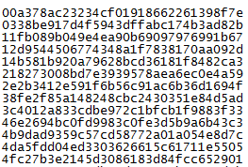
The distribution of objects under the parent directory
Bucket(Total 100)
::::::::::::::::::
:::::::::::::::::::

Figure A11 : The object distribution with S3 policy

(5)The first and second directories distribution with the swift policy is respectively shown in figure B11,B12 when the number of objects up to 100.
partition
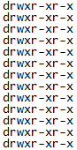
Suffix_path(count:100)
::::::::::::::::::
:::::::::::::::::::

Figure B11: The directory distribution of the first layer with swift policy

Seen from the perspective of probability theory, Hash_name directory distribution is approximately the same under each Suffix. Therefor, take a Suffix_path directory randomly, and observe the directory distribution of the Hash_name.
Suffix_path
Hash_name

Figure B12: The directory distribution of the second layer with swift policy

(6)The first ,second and thord directories distribution with the FDDM policy is respectively shown in figure C11,C12,and C13 when the number of objects up to 100.
UserID

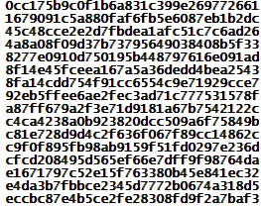
The first directory
distribution under the
user folder (count16)

Figure C11: The directory distribution of the first layer with FDDM policy

Take a directory randomly from the first directory.Observe the subdirectory distribution under the first directory.
The first directory
The subdirectory under the
first directory(Total：5)

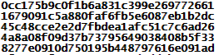

Figure C12: The directory distribution of the second layer with FDDM policy

Take a directory randomly from the second directory as shown above，observer the object distribution under the second directory.

The second directory
The object distribution under the second directory
Figure C13: The directory distribution with the last layer of FDDM policy

Analysis: Seen from the perspective of probability theory, each directory should be distributed evenly.And in the real environment,we can find that the maximum and minimum number of directory of each layer is almost the same as the average number of directory.Therefore, We analysis the directory distribution by studying the average number directory of each layer during the experiment. (Take the object as directory).
Test two：The number of object grows from 100 to 500.
Known from the policy of S3, all of the objects are stored under the bucket.Therefore,we only list the directory distribution respectively with the policy of swift and FDDM.
(1) The number of the first directory changes under the policy of swift,FDDM
as shown in figure b21, c21.
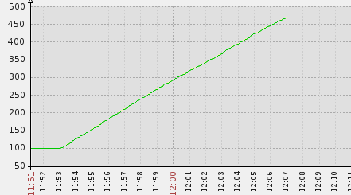
Figure b21: The line chart of the first directory changes with the policy of swift

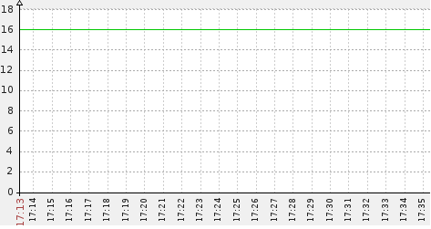
Figure c21: The line chart of the first directory changes with the policy of FDDM

(2)The number of the second directory changes under the policy of swift,FDDM
as shown in figure b22, c22.
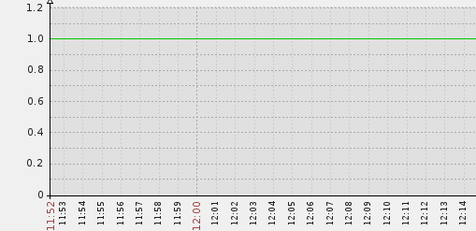
Figure b22: The line chart of the second directory average changes with the policy of swift

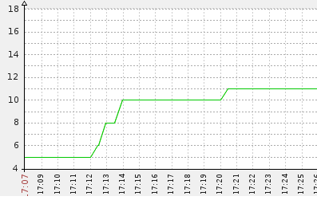
Figure c22: The line chart of the second directory average changes with the policy of FDDM

(3)The number of the third directory changes with the policy of FDDM
as shown in c23：
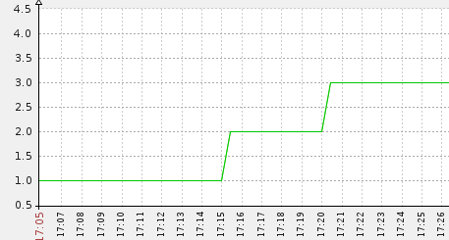
Figure c23: The line chart of the third directory average changes with the policy of FDDM

(4)When the number of the object up to 500 in the system,suffix_path directory distribution under the Partition with the swift policy is shown in figure B12.Seen from B11,B12,We can find there is an increase in the number of suffix_path directory.There is almost only a subdirectory suffix_path under each parent directory suffix_path,and few suffix_path directory own two subdirectories,as shown in figure B22.
Figure B22: The Hash_name directory distribution under parent directory Suffix_path

(5)When the number of the object up to 500 in the system,The directory distribution with the policy of FDDM is shown as follows.The directory of the first layer has been stabilized, and will not change anymore.The distribution is shown in figure C11.Take the same parent directory as C12,C13 to observe the directory distribution of the second and third layers.Shown in figure C22,C23.

A directory of the first layers
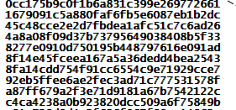
The subdirectories under the first layers
（Total Count：11）

Figure C22: The directory distribution of the second layer with FDDM policy

A directory of the second layers

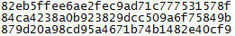
Figure C22: The objects distribution of the third layer with FDDM policy

Analysis: We only take a hexadecimal number from each segment OID to generate directory name of each layer.So there are most 16 directories in each layers.Figure C21 shows that the first layer has reached to 16 directories. The directory of the first layer has stabilized. Therefore,We will no longer observe the directory of the first layer with the FDDM policy.
Test three：The number of object grows from 500 to 1000.
(1)The number of the first directory changes under the policy of swift,FDDM
as shown in figure b31, c31.
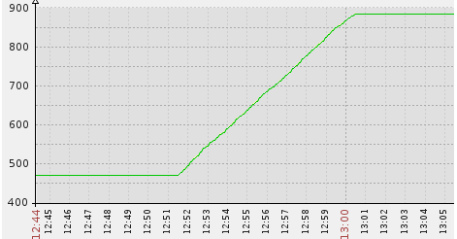
Figure b31: The line chart of the first layer directory changes with swift policy

Figure c31: The line chart of the first layer directory changes with FDDM policy

(2)The average number of the subdirectories under the suffix_path directory with swift policy is not changeThe same as figure b22. The changes of the second layer directory number with FDDM policy is shown in figure c32.
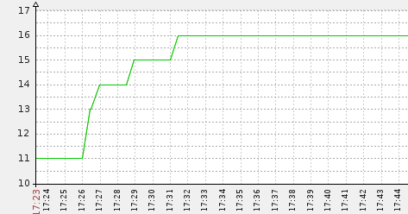
Figure c32: The line chart of the second layer directory changes with FDDM policy

(3)The number of the third directory changes with the policy of FDDM
as shown in c33.
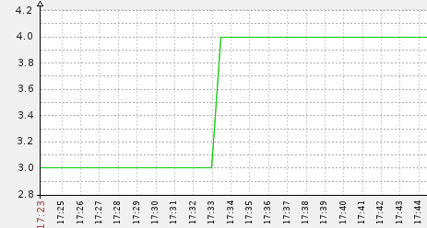
Figure c33: The line chart of the third layer directory changes with FDDM policy

(4)When the number of the object stabilize to 1000 with the swift policy.Just the number of the first directory increase.The number of the subdirectory of the first directory is almost 1.and not change.Therefore,here no longer continue to talk.
(5) When the number of the object stabilize to 1000 with the FDDM policy,According to the policy,we can find the second directory has already stabilized.Shown as figure C32.Take the same parent directory as C12,C13 to observe the directory distribution of the second and third layers.Shown in figure C32,C33.
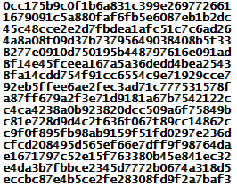
The first layer directory
The subdirectories of the first directory(Total count：16)

Figure C32: The directory distribution of the second layer with FDDM policy

The second layer directory
The object distribution of the last layer

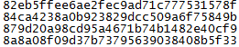
Figure C33: The directory distribution of the last layer with FDDM policy

Test four：The number of object grows from 1000 to 2000.
(1)The directory of the first layer keeps stabilized with FDDM policy. As shown in figure in c31.Here no longer continue to talk.The change of the first directory with swift policy is shown as figure b41.
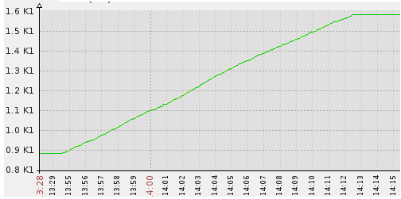
Figureb41: The line chart of the first layer directory changes with swift policy

Wherein：K1：it represents 1000 times。
(2)The average number of the subdirectories under the suffix_path directory with swift policy is not change.The same as figure b22. The changes of the second layer directory number with FDDM policy is shown in figure c42.
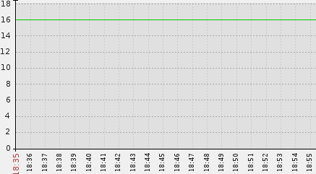
Figure c42: The line chart of the second layer directory changes with FDDM policy

(3) The number of the third directory changes with the policy of FDDM
as shown in c43.
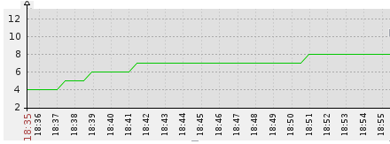
Figure c43: The line chart of the Third layer directory changes with FDDM policy

(4)When the number of the object stabilize to 2000 with the swift policy.Just the number of the first directory increase.The number of the subdirectory of the first directory is almost 1.and not change.Therefore,here no longer continue to talk.
(5)When the number of the object stabilize to 2000 with the FDDM policy,According to the policy,we can find the first and second directories have already stabilized.Therefore,we only observe the number change of the last layer directory.Take the same parent directory as C13 to observe the directory distribution of the last layers.Shown in figure C43.
A Second layer directory
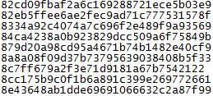
The object distribution of the last layer

FigureC43: The directory distribution of the last layer with FDDM policy

Test five：The number of object grows from 2000 to 5000.
(1) The directory of the first layer keeps stabilized with FDDM policy. As shown in figure in c31.Here no longer continue to talk.The change of the first directory with swift policy is shown as figure b51.
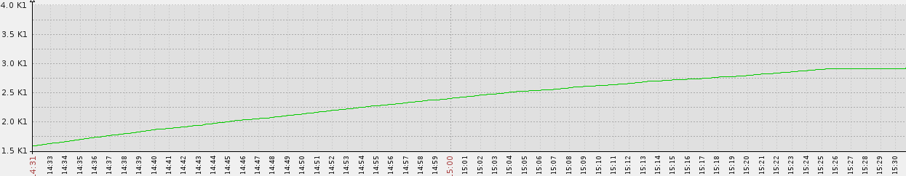
Figureb51: The line chart of the first layer directory changes with swift policy

Wherein：K1：it represents 1000 times。
(2)The directory of the second layer keeps stabilized with FDDM policy. As shown in figure in c42.The change of the second directory with swift policy is shown as figure b52.
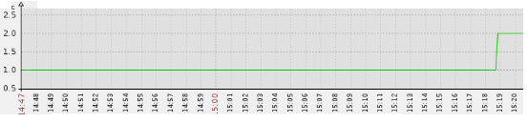
Figure b52: The line chart of the second layer directory changes with swift policy

(3)The change of the third directory with FDDM policy is shown as figure c53.
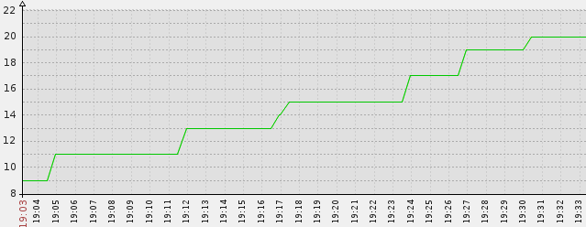
Figure c53: The line chart of the third layer directory changes with FDDM policy

(4)When the number of the object stabilize to 5000.take two Suffix_path directories randomly.Observe the change of the average number of the second layer directory with swift policy. Shown in figure B52.

Suffix_path

Hash_name
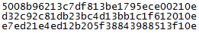
Suffix_path
Hash_name
Figure B52: The hash_name subdirectory distribution under Suffix_path directory with swift policy

- When the number of the object up to 5000.Under the policy of the FDDM,Take a directory of the second layer randomly,and observe the subdirectory distribution
shown in fig C53.
A directory of the second layer

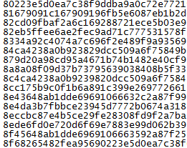
Objects distribution

FigureC53: The objects distribution of the last layer with the FDDM policy

Test six：The number of object grows from 5000 to 10000.
(1)The directory of the first layer keeps stabilized with FDDM policy. As shown in figure in c31.The change of the first directory with swift policy is shown as figure b61.
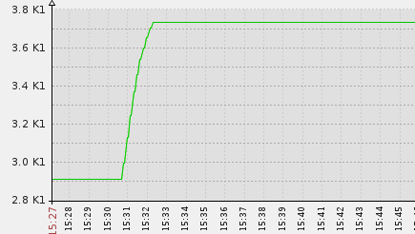
Figureb61 :The line chart of the first layer directory changes with swift policy

(2)The directory of the second layer keeps stabilized with FDDM policy. As shown in figure in c42.The change of the second directory with swift policy is shown as figure b62.
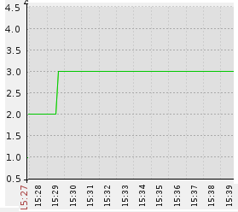
Figure b62: The line chart of the second layer directory changes with swift policy

(3)When the number of the object grows from 5000 to 10000,the change of the last directory with FDDM policy is shown as figure c63.
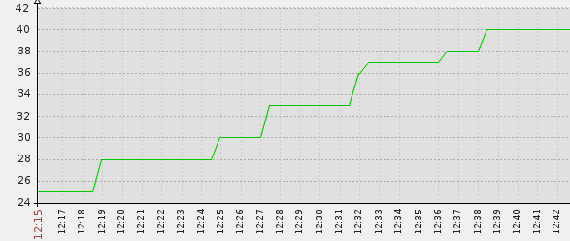
Figure c63: The line chart of the third layer directory changes with FDDM policy

Test seven：The number of object grows from 10000 to 20000.
- The directory of the first layer keeps stabilized with FDDM policy. As shown in figure in c31.The change of the first directory with swift policy is shown as figure b71.

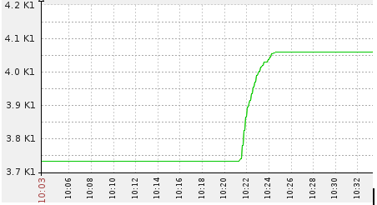
Figureb71: The line chart of the first directory with swift policy
(2)The directory of the second layer with the policy of FDDM has been stabilized.Shown as figure c42.The change of the second directory with swift policy is shown as figure b72.
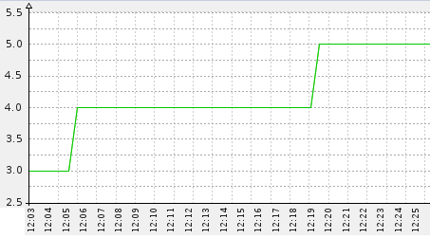
Figure b72: The average change of subdirectory hash_name under the directory Suffix_path with swift policy

(4)The change of the third directory with FDDM policy is shown as figure c73.
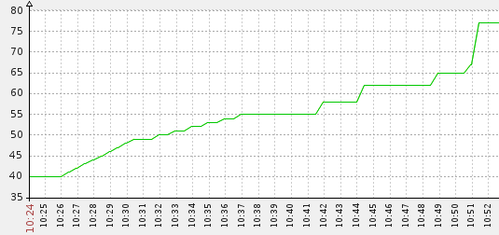
Figure c73: The line chart of the third layer directory changes with FDDM policy

Summarized from the above experimental data,When the object number of each user stabilized to the following points,As 100,500,1000,2000,5000,10000,20000,
The correlation table between the number of each directory under the policy of S3,Swift and FDDM is shown in table 2:
Directory  number  Policy | Directory hierarchy | S3 | Swift | FDDM
100 | The first layer | 100 | 100 | 16
100 | The second layer | 0 | 1 | 5
100 | The third layer | 0 | 1 | 1
500 | The first layer | 500 | 469 | 16
500 | The second layer | 0 | 1 | 11
500 | The third layer | 0 | 1 | 3
1000 | The first layer | 1000 | 886 | 16
1000 | The second layer | 0 | 1~2 | 16
1000 | The third layer | 0 | 1 | 4
2000 | The first layer | 2000 | 1584 | 16
2000 | The second layer | 0 | 1~2 | 16
2000 | The third layer | 0 | 1 | 8
5000 | The first layer | 5000 | 2910 | 16
5000 | The second layer | 0 | 2 | 16
5000 | The third layer | 0 | 1 | 20
10000 | The first layer | 10000 | 3730 | 16
10000 | The second layer | 0 | 3 | 16
10000 | The third layer | 0 | 1 | 40
20000  Table2 : The comparison table of the directory number of each layer under the policy of S3,swift,FDDM | The first layer | 20000 | 4096 | 16
 | The second layer | 0 | 5 | 16
 | The third layer | 0 | 1 | 77

According to the table 2,Draw the comparison Line chart of each layer directory under the policy of S3,Swift and FDDM,as shown in figure A,B,and C respectively. and analyse the variation trend of each directory under each policy.
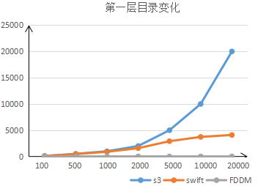
Figure A : The variation trend of the first layer directory under each policy

Wherein: X-axis represents the number of objects in the system.
Y-axis represents the number of the directory.
The blue broken line represents the policy of S3.
The orange broken line represents the policy of swift.
The Blue broken line represents the policy of S3.
The gray broken line represents the policy of FDDM.
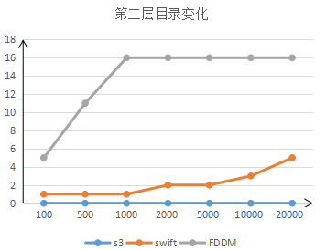
Figure B: The variation trend of the second layer directory under each policy

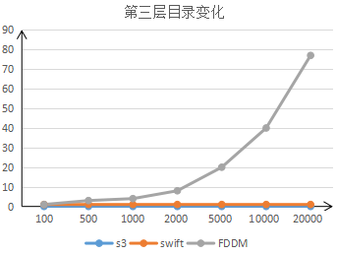
Figure C: The variation trend of the third layer directory under each policy

Analysis
We can draw some conclusion from figure A,B,C.As follows,W\All of the objects storage under the directory of bucket with the S3 policy. Therefore,With the increasement of the object number,the number of the first layer directory is proportional growth.All of the user data is stored under a Single directory.Under
the policy of swift,With the increasement of the object number.The number of the first layer directory is almost linear growth,but the number of the second layer
always maintain a directory at the beginning, it is gradually slow growth when the number of the object more than 10000,according to the policy of Swift,there are always a directory in the third layer directory.With the policy of FDDM,we can find when the number of the object up to 100,The number of the first layer directory
maintain at 16.The number of the second layer directory gradually increase at the beginning,and finally stabilize to 16.With the increasement of the object number,the directory number of the third layer grow slowly.Learn from figure A,B,and C.When the number of the object up to 20000,with the policy of s3,the number of the subdirectory up to 20000 under the single directory.With the policy of Swift,the
number of subdirectories is more than 4,000 under a single directory.With the policy of FDDM,there are most 70 subdirectories under a single parent directory.It can be predicted,When the amount of the user data is G level in the system.With the policy of S3,The number of the subdirectory will up to G level under a single directory.
With the policy of Swift,The number of the subdirectory will up to M level under a single directory.Because too many subdirectories under a single directory, seriously affecting the access performance of the system.If with the policy of FDDM,When the number of the user data keep increasing in the system. you can dynamically expand the directory hierarchy, or expand the capacity of each directory to disperse data uniformly.
We can draw some conclusion from the analysis,as follows, with the policy of S3 does not achieve flat data distribution.To some extent alleviate the problem of data distribution under the policy of Swift,But with the swift policy,
When the amount of user data at K level,the number of the first level directory has reached to K level,but the second layer is almost a single directory.the data distribute unevenly.When the amount of user data at G level,the number of the second level directory has reached to M level.It will seriously affect access
performance of the system. Proposed strategy in the text---FDDM, It is a
fundamental solution to solve the problem of the directory distribution.
Administrators can base on the amount of user data to configure directory hierarchy and the capacity of each directory dynamically.It not only avoid the problem of
scattered distribution of the directory,but also solve the problem of data too
concentrated distribution when the user data is too large.
IV. Conclusion
In the previous sections,We have a detailed analysis and research to the policy of FDDM,and comparative analysis the distribution of the directory respectively under the policy of S3, Swift and FDDM.Some conclusion can be obtained from the
experimental data,can better achieve the flat distribution of the data in the object storage system when use the policy of FDDM. The distribution of the object is not
limited to the amount of user’s data.Administrators can configurate the directory hierarchy and the capacity of each directory dynamically when use the policy of FDDM. So as to solve the problem of excessive or too little amount of data under a single directory,or the low access efficiency of the user.Moreover,There is
a efficient mapping relationship between the object and memory address has been established.
In order to ensure the system performance.When you use the policy of FDDM,base on the file system type and the amount of user data,referring to Table 1, configurate the directory hierarchy and the capacity of each directory dynamically.

References
[1]Amazon.Amazon Web Service..http://aws.amazon.com/
[2] 刘鹏：云计算（第二版） 电子工业出版社
http://blog.sina.com.cn/s/blog_6e0834c80101eo8v.html
[3]阿里云存储服务OSS基本概念
https://help.aliyun.com/knowledge_detail/5974194.html
[4]腾讯云 COS产品介绍
http://www.qcloud.com/wiki/COS%E4%BA%A7%E5%93%81%E4%BB%8B% E7%BB%8D
[5]新浪云存储 开发指南
http://open.sinastorage.com/?c=doc&a=guide
[6]余兴超：深入云存储系统swift存储节点
[7]http://www.cnblogs.com/yuxc/archive/2012/07/04/2575536.html
对象存储系统Swift技术详解：综述与概念
http://www.cnblogs.com/yuxc/archive/2011/12/06/2278303.html
[8] Zhenzhong Zhang1, Limin Xiao1*,Yuan Tao1
A Model Based Load-Balancing Method in IaaS Cloud
[9] 谢华成,陈向东：面向云存储的非结构化数据存取[J].计算机应用
2012.32(7):1924-1928
[10] Hayes B. Cloud Computing [J]. Communications of the ACM, 2008, 51(7): 9-11
[11] 范中磊.网络存储技术漫谈之一：网络存储简介[J].记录媒体技术.2010,03:53~56
[12] http://www.zhihu.com/question/21536660
[13] 周敬利，周正达: 改进的云存储系统数据分布策略
计算机应用 2012-02-01
[14] 黄秋兰，武杰，程耀东，陈刚:海量存储系统的数据分布策略研究
[分类号：TP333] 2013-11-25
[15] 喻占武，郑胜，李忠民，胡滨：基于对象存储的海量空间数据存储与管理
学术论文（2008年05期）

